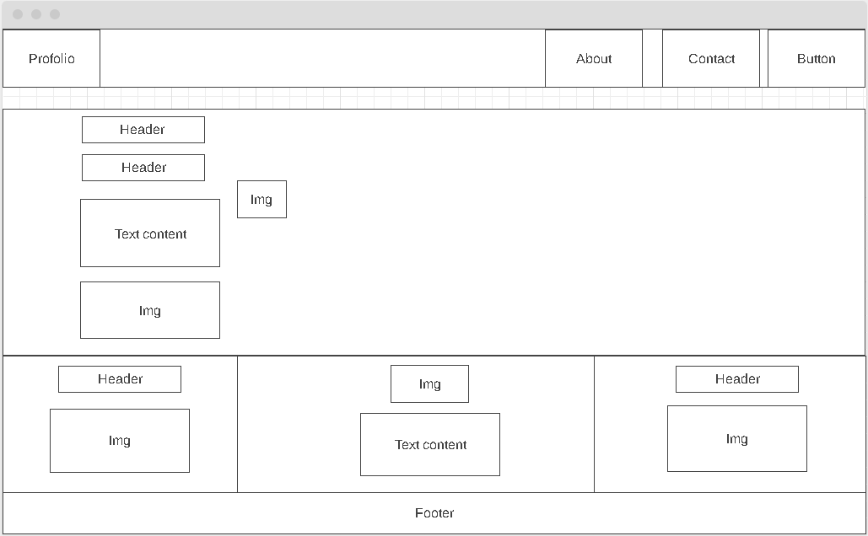

Font-Size: 2.2vh

Font-Size: 2vh

Font-Size: 2.1vh

Font-Size: 2.1vh

Font-Size: 2vh

Font-Size: 2vh

Font-Size: 2vh

2 Background Images For light and dark Mode

Light Mode Background: Grey

Background: black